**Project Proposal: ShowCase Web Application**

### **Title**

ShowCase Web Application—A Platform for Skill Showcasing, Networking, and Collaboration

### **1. Introduction**

The ShowCase Web Application is an interactive online platform designed to help users showcase their skills, share knowledge, connect with others, and collaborate on projects. The system allows users to search for skills, view related posts, interact with other users, and maintain detailed personal profiles. With integrated communication tools, the platform fosters a learning and professional networking environment.

### **2. Background Study**

In today’s digital era, professional networking platforms such as LinkedIn have become popular; however, they often cater to highly experienced professionals, leaving little room for students, freelancers, and recent graduates to showcase their skills in an engaging way. The ShowCase Web Application aims to bridge this gap by focusing on:

* A skill-based search system and filtering option.
* Interactive communication features.
* Profile customization with multimedia content.
* Opportunities for collaboration and learning.
* Share their skills, upcoming events, and related jobs.

This project draws inspiration from existing social networking and job-hunting platforms but adapts them to create a more inclusive, skill-focused environment.

### **3. Objectives**

* **Primary Objective:** Develop an interactive platform that allows users to showcase their skills, connect with others, and collaborate on projects.
* **Specific Objectives:**
  1. Allow users to create and manage detailed profiles.
  2. Implement skill-based search and filtering features.
  3. Provide functionalities for liking and viewing content.
  4. Enable post/event/job creation, editing, and deletion.
  5. Support direct communication between users and the system. Also, communication between users.

### **4. Methodology**

The project will be developed using an Agile development approach, ensuring iterative development and continuous feedback.

**Steps:**

1. **Requirement Analysis:** Gather functional and non-functional requirements using Google Forms.
2. **Design Phase:**
   * Create wireframes and mockups.
   * Prepare use case diagrams and workflow models.
3. **Development Phase:**
   * **Frontend:** HTML, CSS, Tailwind, JavaScript.
   * **Backend:** PHP, MySQL for database management.
4. **Testing:** Unit testing, integration testing, and user acceptance testing.
5. **Deployment:** Host on a cloud server with user access.

### **5. Challenges Faced**

* Designing a user-friendly yet feature-rich interface.
* Ensuring secure authentication and data protection.
* Managing database optimization for fast search queries.
* Balancing between minimalism and functionality in UI.
* Implementing smooth real-time communication between users.

### **6. Updated Timeline**

|  |  |  |
| --- | --- | --- |
| Phase | Duration | Timeline |
| Requirement Analysis | 1 week | Week 1 |
| Design Phase | 2 weeks | Week 2-3 |
| Development Phase | 5 weeks | Week 4-8 |
| Testing | 2 weeks | Week 9-10 |
| Deployment | 1 week | Week 11 |

### **7. Project Management and Financial Analysis**

**Project Management:**

* **Team Roles:**
  + Project Manager: Oversees progress.
  + Frontend Developer: UI/UX and client-side features.
  + Backend Developer: Server-side logic and database integration.
  + QA Tester: Ensures quality control.

**Financial Analysis:**

* Development Tools**:** Free & open-source (PHP, MySQL, Tailwind).
* Hosting**:** 6,000 BDT/year (approx.).
* Domain Name**:** 1,200 BDT/year (approx.).
* Miscellaneous**:** 5,000 BDT for graphics, icons, and templates.
* Total Estimated Cost: 12,200 BDT/year.

### 

### **8. Detailed Explanation**

The ShowCase Web Application workflow begins with user authentication (login/sign-up). Users can then search for skills, filter categories, view results, and interact with posts. They can like posts, view details, or visit other users’ profiles. Profile owners can create, edit, and delete posts, as well as update their profiles with new content. A communication feature enables both user-to-user interaction and system notifications.

### **9. Features**

* User Authentication (Sign Up / Log In).
* Skill Search & Filtering.
* Profile Creation & Customization.
* Post Creation, Editing, and Deletion.
* Like and View Details.
* Direct messaging between users and systems.
* Category Filtering for Content Discovery.

### **10. Benefits**

* Encourages networking among students, professionals, and freelancers.
* Allows users to maintain a dynamic portfolio.
* Provides easy skill discovery and collaboration opportunities.
* Improves personal branding and visibility.
* User-friendly interface and interactive experience.

### **11. Use Case Diagram**

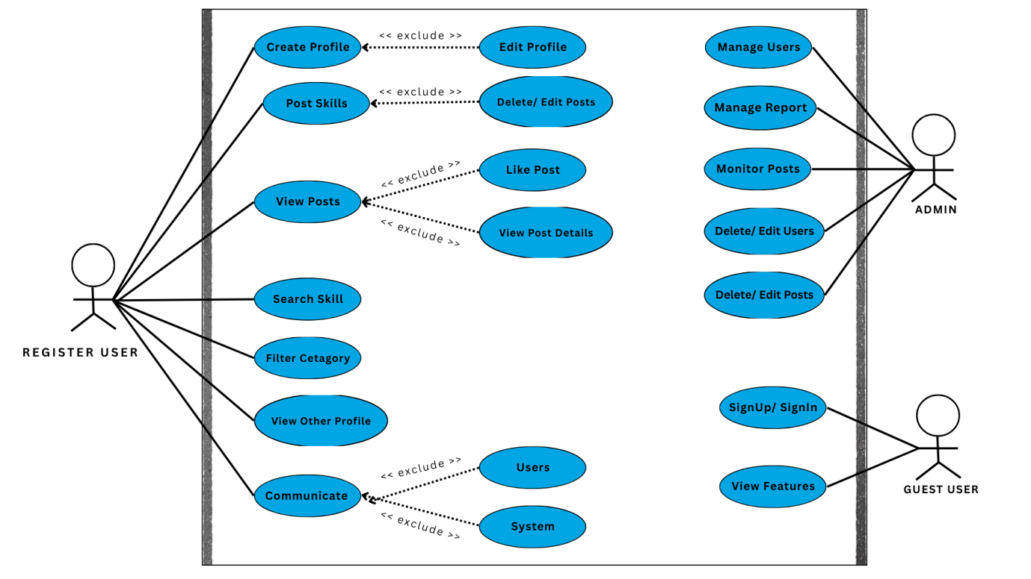

**Fig:** Use Case Diagram for the ShowCase Web Application.

### **12. Activity Diagram**

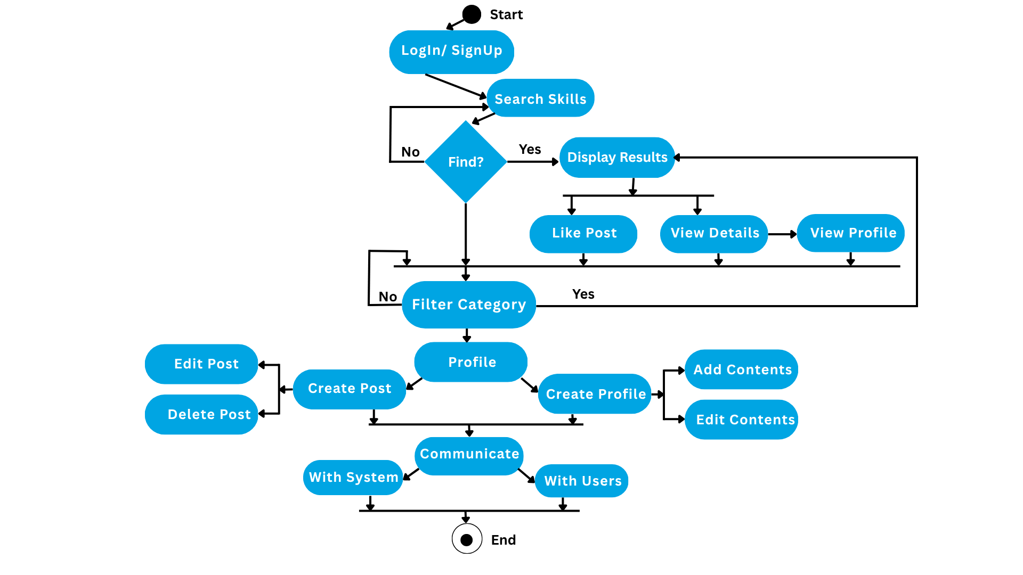

**Fig:** Activity Diagram for the ShowCase Web Application.

### **13. Sequence Diagram**

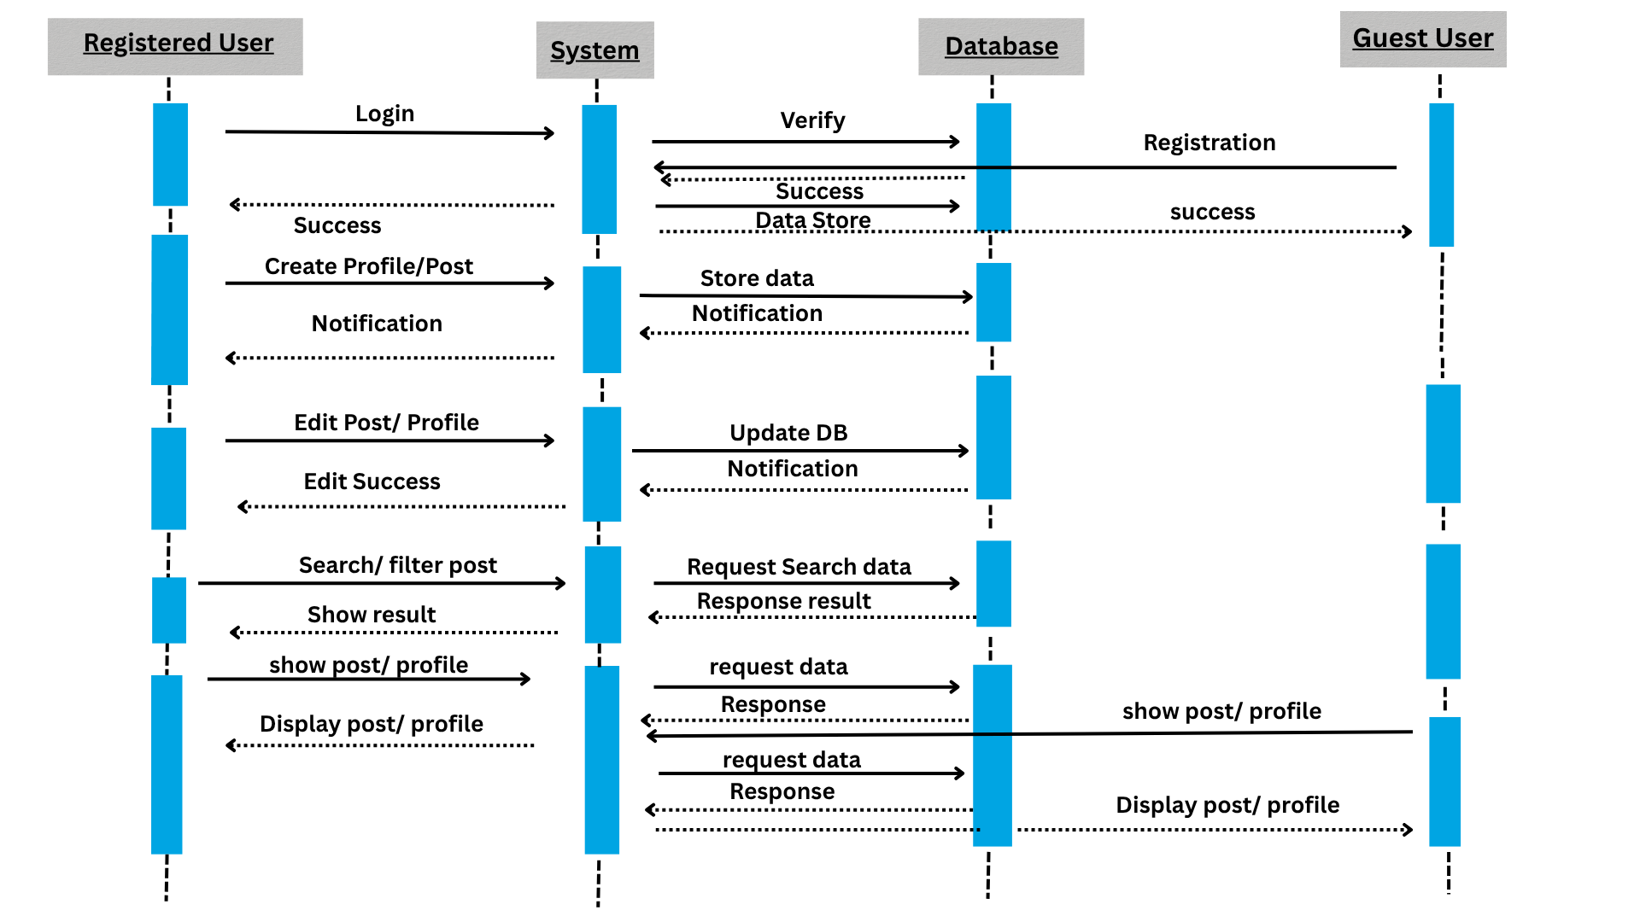

### 

### **14. Conclusion**

The ShowCase Web Application offers an innovative solution for skill showcasing, networking, and collaboration. By combining profile management, post creation, communication, and search functionalities into one platform, it creates a productive environment that fosters both personal growth and professional connections. With an intuitive interface and cost-effective structure, this project has significant potential for academic, freelance, and industry use.